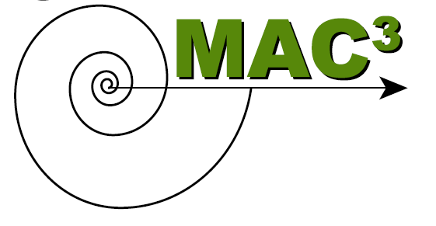
Math Across the Community College Curriculum
Traveling Workshop Agenda
Purchase College, SUNY
April 10, 2010

10:00 – 10:30 Introductions
Introduction of MAC³, facilitator, and attendees; discuss goals and agenda.

10:30 –11:30 Issues, Strategies & Examples
Discussion of challenges and pedagogical issues of interdisciplinary work. Examples given of integrating math and science content. Do graphing exercise.

11:30 – 12:00 Brainstorming
Divide into teams by school/discipline to brainstorm possible topics for curriculum development.

12:00 – 1:00 Lunch & Continued Discussions

1:00 – 1:30 Group Discussion
Come back together to discuss issues raised at lunch and share solutions and resources.

1:30 – 2:30 Team Work Time
Start work on designing a lesson/module. Discuss implementation details.

2:30-3:00 Wrap-up, Reporting, and Next-Steps
Each group/person will give 2-minute report on their planned curricular project. Discuss any other perceived challenges or questions. Conclude with where to go from here.

